**DAY 9 – CLASS EXERCISES**

**CLASS EXERCISE 1**

**package** com.softwaretest1.demo1;

**import** org.testng.annotations.Test;

**import** org.testng.annotations.DataProvider;

**public** **class** Day9_CE1 {

@Test(dataProvider = "dp")

**public** **void** add(Integer n1, Integer n2) {

System.***out***.println("Addition: ");

System.***out***.println(n1+n2);

}

@Test(dataProvider = "dp")

**public** **void** sub(Integer n1, Integer n2) {

System.***out***.println("Subtraction: ");

System.***out***.println(n1-n2);

}

@Test(dataProvider = "dp")

**public** **void** prod(Integer n1, Integer n2) {

System.***out***.println("Multiplication: ");

System.***out***.println(n1*n2);

}

@Test(dataProvider = "dp")

**public** **void** div(Integer n1, Integer n2) {

System.***out***.println("Division: ");

System.***out***.println(n1/n2);

}

@DataProvider

**public** Object[][] dp() {

**return** **new** Object[][] {

**new** Object[] { 10, 5 },

**new** Object[] { 8, 4 },

};

}

}

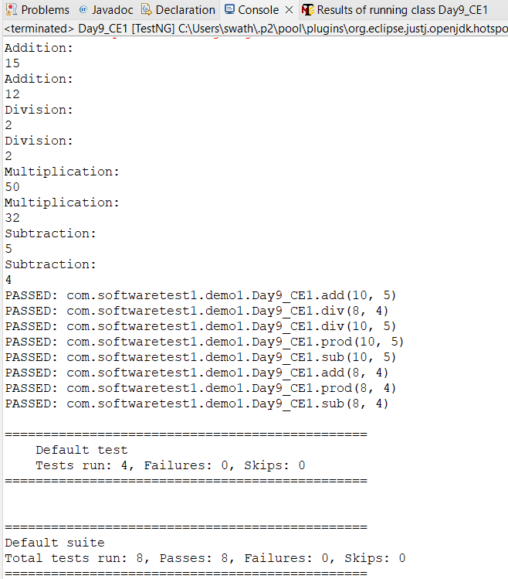

**CLASS EXERCISE 2**

**package** com.softwaretest1.demo1;

**import** java.util.concurrent.TimeUnit;

**import** org.openqa.selenium.By;

**import** org.openqa.selenium.WebDriver;

**import** org.openqa.selenium.chrome.ChromeDriver;

**import** org.openqa.selenium.chrome.ChromeOptions;

**import** org.testng.Assert;

**import** org.testng.annotations.Test;

**import** io.github.bonigarcia.wdm.WebDriverManager;

**public** **class** Day9_CE2_01 {

@Test

**public** **void** test1() {

ChromeOptions co = **new** ChromeOptions();

co.addArguments("--remote-allow-origins=*");

WebDriverManager.*chromedriver*().setup();

WebDriver driver = **new** ChromeDriver(co);

driver.get("https://www.godaddy.com/en-in");

driver.manage().window().maximize();

String actualTitle=driver.getTitle();

String expectedTitle="Domain Names, Websites, Hosting & Online Marketing Tools - GoDaddy IN";

Assert.*assertEquals*(actualTitle,expectedTitle);

String actualUrl = driver.getCurrentUrl();

String expectedUrl = "https://www.godaddy.com/en-in";

Assert.*assertEquals*(actualUrl, expectedUrl);

driver.close();

}

@Test

**public** **void** test2() {

ChromeOptions co = **new** ChromeOptions();

co.addArguments("--remote-allow-origins=*");

WebDriverManager.*chromedriver*().setup();

WebDriver driver = **new** ChromeDriver(co);

driver.get("https://www.godaddy.com/en-in");

driver.manage().window().maximize();

driver.manage().timeouts().~~implicitlyWait~~(10,TimeUnit.***SECONDS***);

driver.findElement(By.*xpath*("//*[@id=\"id-631b049a-e9c0-4d24-8710-c504745206dd\"]/div[2]/div[1]/ul/li[1]/button")).click();

driver.findElement(By.*xpath*("//*[@id=\"id-631b049a-e9c0-4d24-8710-c504745206dd\"]/div[2]/div[1]/ul/li[1]/div/div[2]/div[1]/ul/li[2]/a")).click();

driver.close();

}

@Test

**public** **void** test3() {

ChromeOptions co = **new** ChromeOptions();

co.addArguments("--remote-allow-origins=*");

WebDriverManager.*chromedriver*().setup();

WebDriver driver = **new** ChromeDriver(co);

driver.get("https://www.godaddy.com/en-in");

driver.manage().window().maximize();

driver.manage().timeouts().~~implicitlyWait~~(10,TimeUnit.***SECONDS***);

driver.findElement(By.*xpath*("//*[@id=\"id-631b049a-e9c0-4d24-8710-c504745206dd\"]/div[2]/div[1]/ul/li[1]/button")).click();

driver.get("https://www.godaddy.com/en-in/domains");

String actualTitle=driver.getTitle();

System.***out***.print(actualTitle);

String expectedTitle="GoDaddy Domain Search - Buy and Register Available Domain Names";

Assert.*assertEquals*(actualTitle,expectedTitle);

driver.close();

}

}

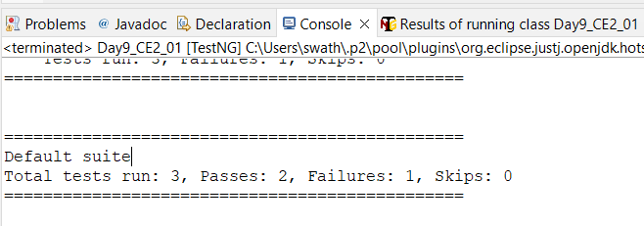

**CLASS EXERCISE 4**